Name: Cap Bao Tram, Mike, Lucas, Jacky

USING COMPOUND MICROSCOPES
Date: October 16, 2016
Honor code: On my honor, I have neither received nor given any unauthorized aid on this assignment.

INTRODUCTION
Compound microscope is an instrument for forming enlarge picture of small objects, including of an objective lenses with a very short focal length and an eyepiece with a longer focal length, both lenses mounted in the same tube.
We used the compound microscope when we want to observe microscopic organisms that are too small for the naked human eye to see. It was invented by Zacharias Jansen and his father in 1595. They put several lenses in a tube and they discovered that the object that near the end of the tube appeared to be greatly enlarged, larger than any simple magnifying glass could achieve by itself.

There are many types of microscopes and it divided into 3 categories: optical microscopes, electron microscopes, and other
- Optical microscope is use the visible light and a system of lenses to magnifies specimens. ( Compound microscope, stereo microscope, and confocal microscope)
- Electron microscope is scans with electrons rather than visible light, resulting in a very detailed image because of the wavelength of the electrons is much smaller than the wavelength of light from a bulb or laser, allowing for greater detail when scanning. (scanning electron microscope, transmission electron microscope).
- Most other types of microscopes are less common and used by research scientists.( Scanning probe microscope, scanning acoustic microscope, and x-ray microscope)

MATERIALS
Compound microscope
Slide
Cover slide
Forcep
Blade
Toothpicks
Onion
Yogurt
Distilled water
Methylene blue
Gloves
Tissues
Oil immersion
PROCEDURE
- YOGURT UNDILUTE
Step 1: Use a toothpick to take a small amount of yogurt
Step 2: Smear it on the slide
Step 3: Let it dry for 3 minutes
Step 4: Flamed it on the fire for 4 - 5 times
Step 5: Put a few drops methylene blue on the surface ( Wear gloves)
Step 6: Place a cover glass onto the slide, remove any excess solution with a tissue
Step 6: Enter a microscope, adjust the size in order from a lowest magnification to highest magnification ( 4x, 10x, 100x) ( When we observe the slide on 100x, use the oil to observe it more clearly).
- ONION ROOT
Step 1: Use a blade to cut a small root
Step 2: Put a root onto the slide
Step 3: Put a cover glass onto the slide
Step 4: Enter a microscope, adjust the size in order from a lowest magnification to highest magnification ( 4x, 10x,100x) ( When we observe the slide on 100x, use the oil to observe it more clearly)
- ONION CELL
Step 1: Peel the onion
Step 2: Use a forcep, take a piece of onion ( epidermis)
Step 3: Put it on a slide
Step 4: Put a cover slide onto the slide
Step 4: Enter a microscope, adjust the size in order from a lowest magnification to highest magnification ( 4x, 10x, 100x) ( When we observe the slide on 100x, use the oil to observe it more clearly)
- YOGURT DILUTE
Step 1: Dilute the yogurt with the distilled water
Step 2: Use a toothpick, take a small amount of yogurt dilute and smear it onto the slide
Step 3: Let it dry for 3 minutes
Step 4: Flame it on fire for 4-5 times
Step 5: Wear gloves and put a few drops of methylene blue
Step 6: Place the cover slide and remove the excess solution with the tissue
Step 7: Enter the microscope, adjust the size in order from a lowest magnification to highest magnification ( 4x,10x,100x) ( When we observe the slide on 100x, use the oil to observe it more clearly)
- CHEEK CELL
Step 1: Use a toothpick, scrape the inner side of a cheek
Step 2: Smear it on the slide
Step 3: Let it dry for 3 minutes
Step 4: Flame it on the fire for 4-5 times
Step 5: Wear gloves and put a few drops of methylene blue on the surface
Step 6: Place the cover slide and remove the excess solution with the tissue
Step 7: Enter the microscope, adjust the size in order from a lowest magnification to highest magnification ( 4x,10x,100x) ( When we observe the slide on 100x, use the oil to observe it more clearly)
DATA AND RESULTS
- YOGURT UNDILUTE ( 4x, 10x, 100x)
4x: The object is slightly blue and yellow. However our observation is unclear so we can’t see detaily
10x: There are sightly green and blue. The picture was so blurry. I can’t describe the shape however I see it sparse everywhere.
100x: We can’t focus on the slide, however I see many little dots which i guess is a nuclei.
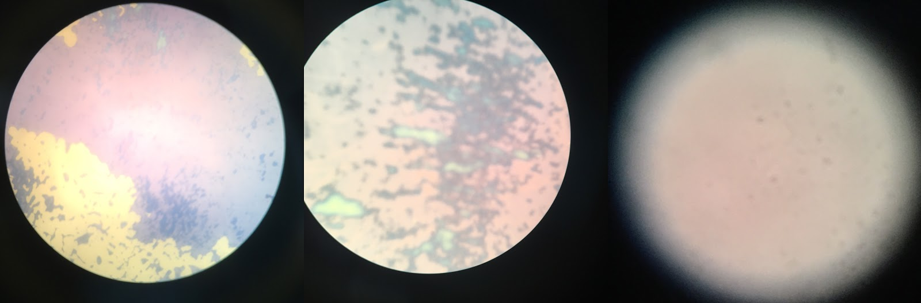

- ONION ROOT ( 4x, 10x, 100x)
4x: The object have a colour green, have feather - shape.
10x: There are some wizen patterns in 10x.
100x: There are many dots placed sparsely 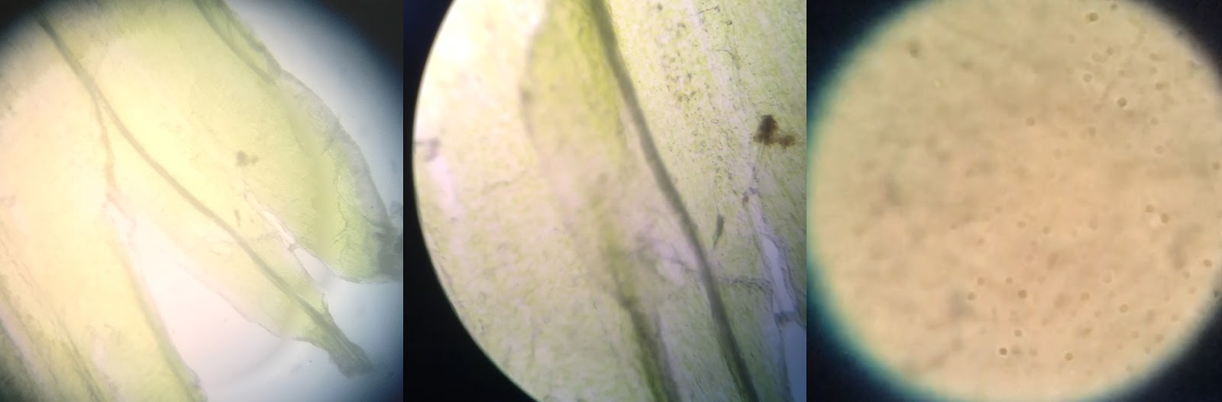
- ONION CELL ( 4x, 10x)
4x: There are look like a block shape.
10x: Have many dots.
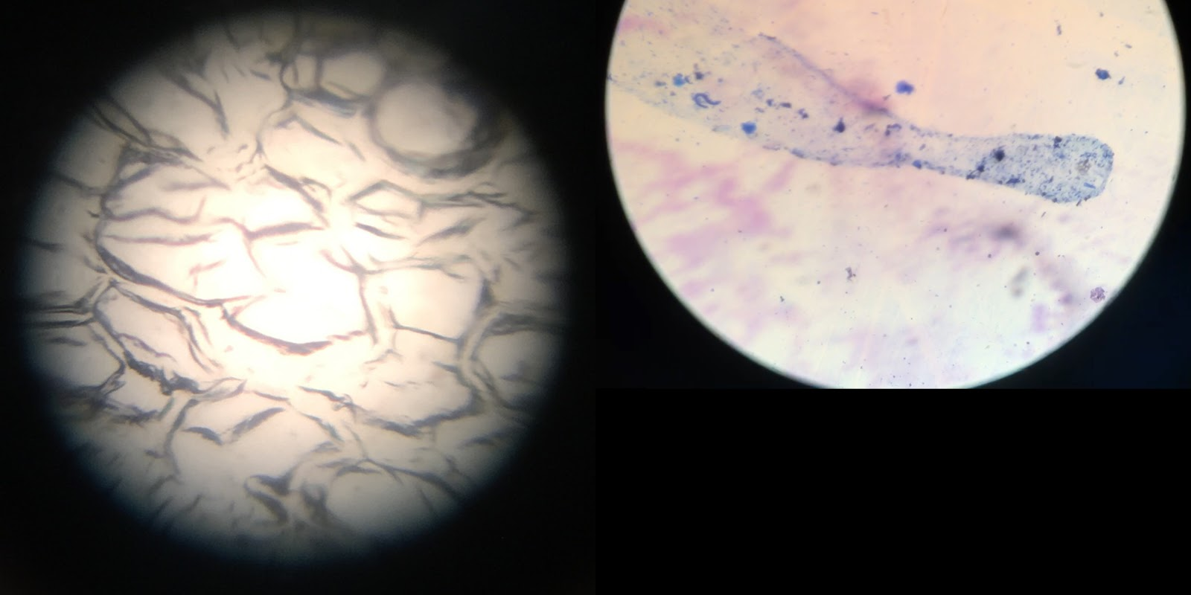

- YOGURT DILUTE ( 4x, 10x, and 100x)
4x: The light gave a effect of light orange pigment color.
10x: The picture is completely unclear, however I can see a few dots on the side of the corner.
100x: There are many dots and also some tiny long shape which may be a bacteria.
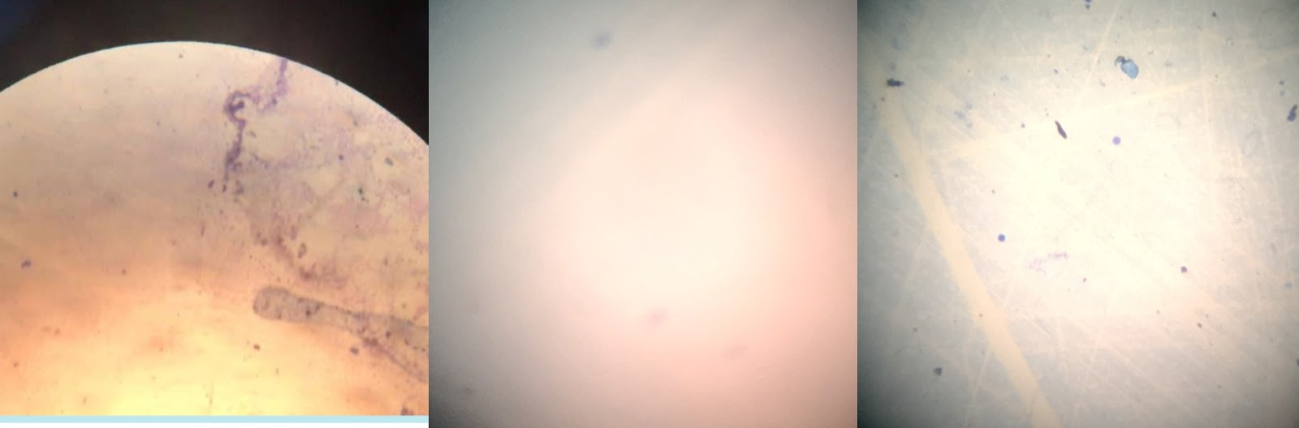
- CHEEK CELL ( 4x, 10x)
- 4x: The color of the cell is blue which was pigmented and it placed sparsely.
100x: Look more closely to the object, it look like a torn up paper shape and it still sparse everywhere.
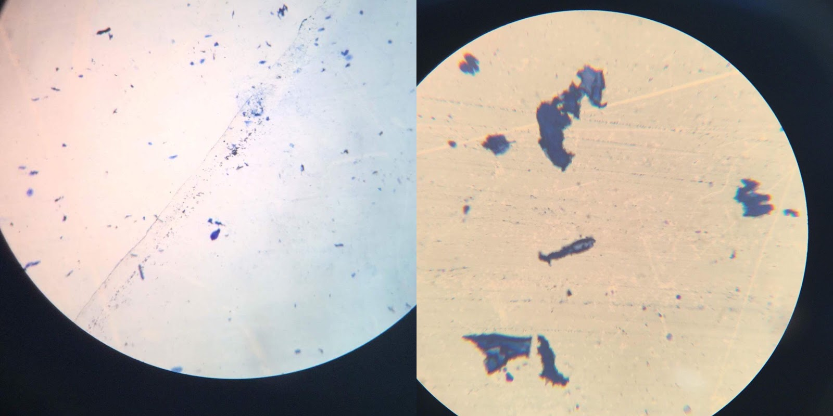DISCUSSION
- 1
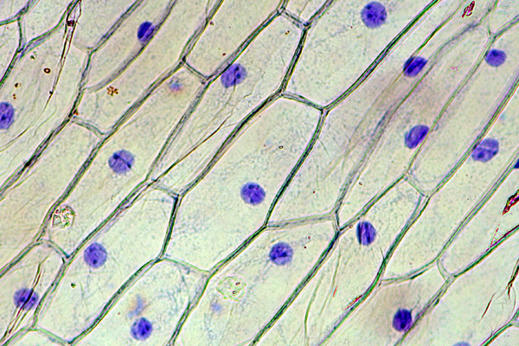Onion cells
http://www.microbehunter.com/staining-of-onion-cell-nuclei/
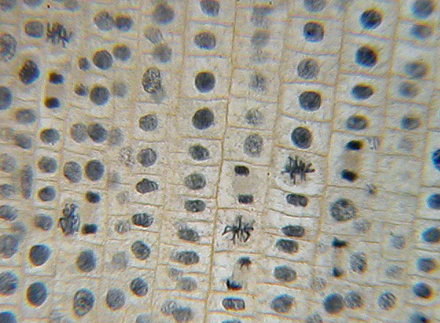Onion root
http://www.instruction.greenriver.edu/kmarr/biology%20211/Labs%20and%20ALEs/B211%20Labs/B211%20Labs/Onion%20and%20Whitefish%20Mitosis/Onion%20Root%20Tip%20Mitosis/Onion%20Root%20tip%20Mitosis.html
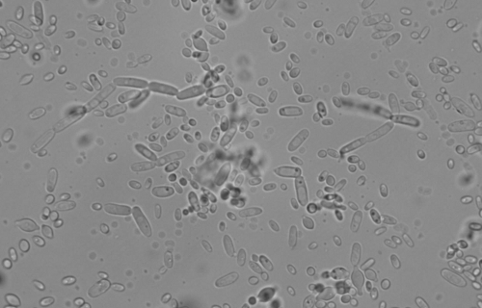Bacteria in yogurt
Some bacteria found commonly in yogurt are S.thermophilus, L.bulgaricus, L.acidophilus, L.casei, L.rhamnosus, Bifidus, and b.bifidum
https://eurekabrewing.wordpress.com/2012/02/05/2-agar-plates-water-kefir-lactobacillus/

- 2
ONION CELL
Shape: rectangular cells, each with a small, spherical nucleus.
Structure:
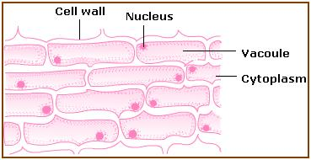
ONION ROOT CELL
Shape: the cells took on a brick-like structure and within the cells, small dots (the nuclei)
Structure:
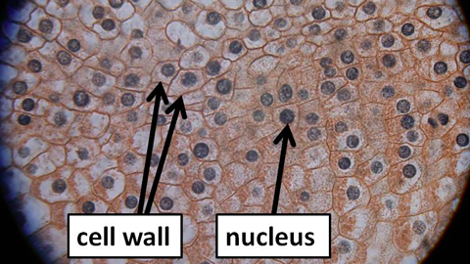
YOGURT
Shape: rod shaped and spherical
Structure: Including Lactobacillus bulgaricus and Streptococcus
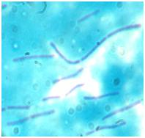

3 COMPARISON
The pictures that our groups take are slightly different from the pictures on the Internet. There are not in high quality and their some samples are ambiguous and unclear as the source on the Internet.

- 4 OPINION
Working in the laboratory is my new experiment, therefore I still confuse in working this project. I have learn a new technique is how to use a compound microscope, how to write a pre lab and lab reports. In the laboratory, I have to be concentrate and working experiment seriously to receive the best results and on time. In my opinion, I think the best way to develop this experiment is read the pre lab, especially the procedure more carefully.

RESEARCH QUESTION
Methylene blue is used for improve visualization of specific ingredients within a cell by dyeing the nuclei of cells. When we working with methylene blue, we have to wear gloves for preventing its spoil on your skin.
The reason for using the oil immersion in the 100x step is because it can improve both resolution and numerical aperture (relates to the light gathering properties of the optical components in the microscope).
How to use:
Step 1: Put a few drops of immersion oil onto the surface of the object
Step 2: Adjust the lenses into 100x
Step 3: Started to observe the object.

